
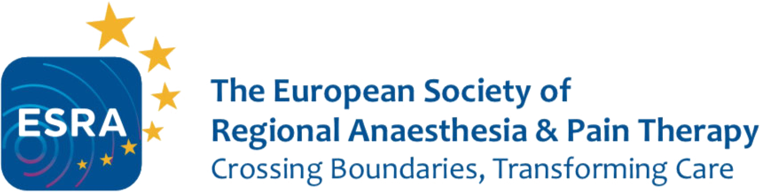

Application form for applicants
ESRA-AOSRA PM Educational Grants

Contact details

First name: Click here to enter text.
Last name: Click here to enter text.
Email address: Click here to enter text.
ESRA member: ☐ yes ☐ no
Please attach CV

Current employment status

Institution: Click here to enter text.
Head of department: Click here to enter text.

Proposed ESRA/AOSRA PM Training Centre

Click here to enter text.

Head of the educational program details

First name: Click here to enter text.
Last name: Click here to enter text.
Email address: Click here to enter text.
ESRA member: ☐ yes ☐ no
AOSRA PM Member: ☐ yes ☐ no

Please attached a written statement of the head of the educational program describing the rotational program and stating that they are prepared to host you in case of a positive decision by the Board

Time frame of the visit Click here to enter text.

Training

☐ Regional anaesthesia
☐ Pain medicine

Personal statement

< 500 words (to be attached)

Please send your application and documents to office@esraeurope.org
ESRA Office, Rue de Chantepoulet 10, 1201 Geneva, Switzerland
Tel: +41 22 510 56 10

Information for applicants ESRA-AOSRA PM Educational Grants

Contact details

Personal information - current contact details - these will be checked by return email to confirm receipt of your application; if these are incorrect your application will be rejected.

Attach current CV with referee’s, who have given consent to be contacted by the ESRA Grants Committee if necessary to validate CV and application.

Current employment status

Present - position/employment (institution and current head of department).
Please discuss your application with your head of department, mentor or clinical tutor.

Proposed AOSRA PM training centre

It is the responsibility of the applicant to have contacted the training centre where they wish to do their extended training prior to making an application. ESRA will need details of the proposed training centre and the contact details of the person who will be responsible for the training.

The duration of the training will need to be specified and proposed dates indicated. Applications can only be made for the forthcoming year and the training must take place within one year of the grant being awarded. There is no provision to extend the time period or defer the attachment (unless in exceptional circumstances).

Personal statement

A personal statement reflecting your need for extended training MUST accompany this application.

Proof of health insurance

It is the responsibility of the applicant to have a health insurance during the visit.

