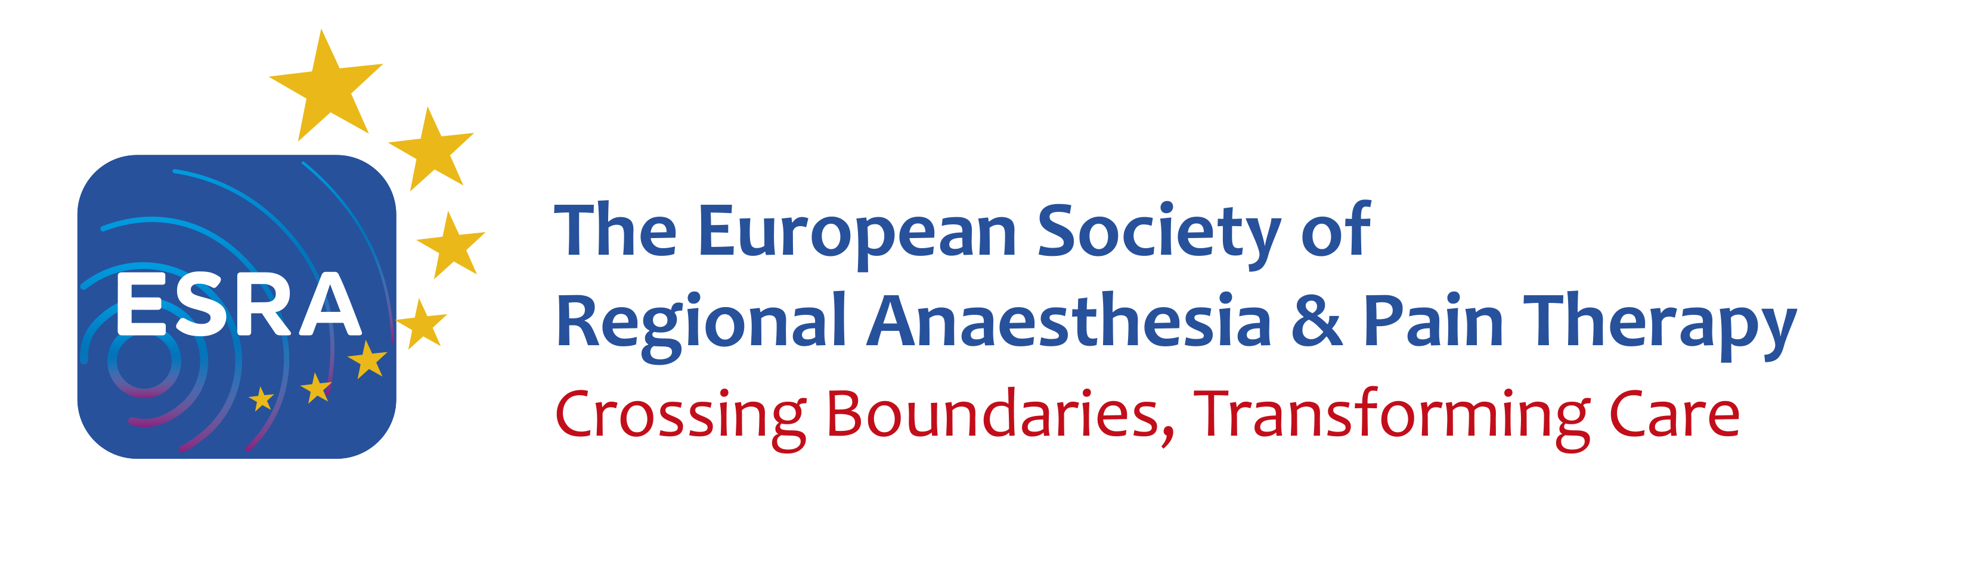
Application form for training institutions

Institution

Name: Click here to enter text.
Address: Click here to enter text.
Website: Click here to enter text.

Date of application: Click here to enter text.

Professor or Head of Department
Email and contact details: Click here to enter text.
No of hospital beds: Click here to enter text.
Approx. no surgery per year: Click here to enter text.
RA training program ☐ yes ☐ no
☐ upper limb, expected number of procedures per year Click here to enter text.
☐ lower limb, expected number of procedures per year Click here to enter text.
☐ thoracic, expected number of procedures per year Click here to enter text.
☐ abdominal, expected number of procedures per year Click here to enter text.
☐ reconstructive, expected number of procedures per year Click here to enter text.
☐ cosmetic, expected number of procedures per year Click here to enter text.
☐ paediatrics, expected number of procedures per year Click here to enter text.
☐ maternity, expected number of procedures per year Click here to enter text.
☐ head and neck, expected number of procedures per year Click here to enter text.
☐ spinal surgery, expected number of procedures per year Click here to enter text.
More details if applicable: Click here to enter text.

Pain Medicine Program ☐ yes ☐ no
☐ interventional pain, expected number of procedures per year Click here to enter text.
☐ SCS, expected number of procedures per year Click here to enter text.
☐ multidisciplinary, expected number of procedures per year Click here to enter text.
More details if applicable: Click here to enter text.

POCUS ☐ yes ☐ no
☐ airway, expected number of examinations per year Click here to enter text.
☐ lung, expected number of examinations per year Click here to enter text.
☐ cardiac, expected number of examinations per year Click here to enter text.
☐ gastric, expected number of examinations per year Click here to enter text.
☐ abdominal, expected number of examinations per year Click here to enter text.
☐ other (specify), expected number of examinations per year Click here to enter text.
More details if applicable: Click here to enter text.

Research areas and publications in the last 5 years:
Click here to enter text.
Can an applicant get involved in a project that can lead to a publication? ☐ yes ☐ no

Responsible Clinical Lead

ESRA member: ☐ yes ☐ no
Email & contact details: Click here to enter text.
Please attach CV & a picture

Teaching staff members

ESRA member ☐ yes ☐ no
Emails & contacts details (max 5)
Click here to enter text.

Training offered

☐ Regional anaesthesia, number of blocks that an applicant could expect to perform:
Click here to enter text.

☐ Pain medicine, mix of patients, how many per year, New vs Review, predominant diagnoses etc.., please specify:
Click here to enter text.

☐ POCUS

Duration

Weeks / months: Click here to enter text.
Observer / Hands –on: Click here to enter text.

Accommodation

Available ☐ yes / ☐ no

Restriction*

On EU or non-EU doctors – please specify
Click here to enter text.

Language requirements

Language requirements – please specify
Click here to enter text.

Additional information to ESRA website

Please provide information or link.
Click here to enter text.

Support from the ESRA national society

Please attach a letter of support from your national society.

*if registration on national medical association, insurance, etc is needed
Please send your application and documents to office@esraeurope.org
ESRA Office, Rue de Chantepoulet 10, 1201 Geneva, Switzerland
Tel: +41 22 510 56 10

