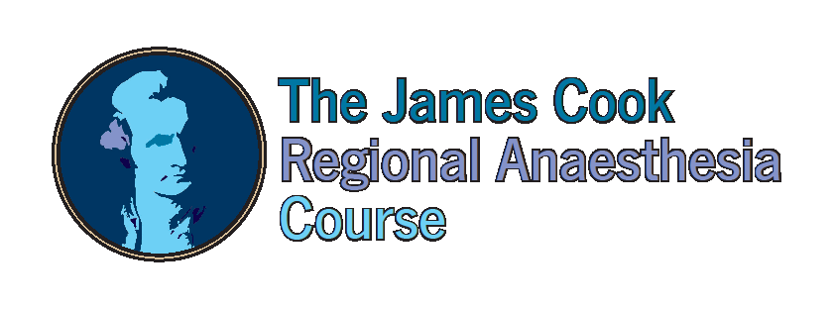

Thursday 11th & Friday 12th April 2019
Hull York Medical School, John Hughlings Jackson Building, University of York, Heslington, York, YO10 5DD (new location!)

Early bird registration £350 (before 4 Jan 2019), Late registration £400
(course dinner available at an additional cost of £25)
apply online at www.jcrac.co.uk or complete and return the attached application form.
Further information contact nicky.robinson@nhs.net or 01642 282534

Approved by RCA for 10 CPD Points, RA-UK approved for EDRA diploma

The 15th James Cook Regional Anaesthesia Course will be held this year in the beautiful city
of York, a comprehensive 2-day course which includes:

- Demonstration of relevant anatomy to regional anaesthetists on cadavers by Anatomy Lecturers at York University
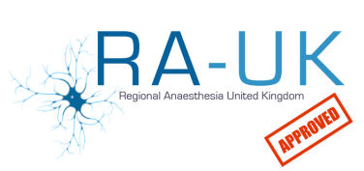
- Small group work teaching (4-5 delegates per instructor)

- Side by side cadaveric learning and scanning on volunteers

- Hands-on learning of needle techniques and catheters on phantoms

- Opportunity to discuss tips and tricks with international experts in ultrasound regional anaesthesia
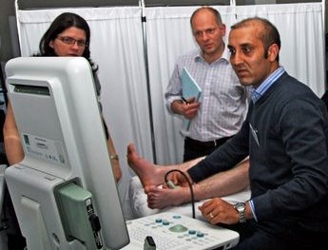
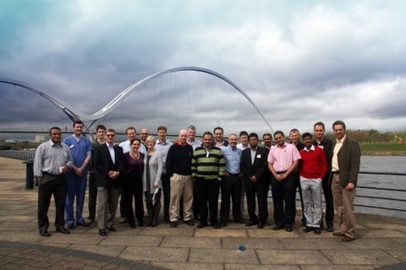
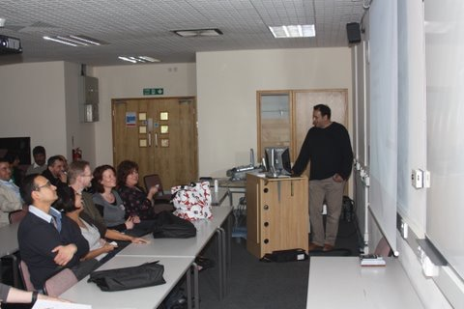

§
“A superb course and very well organised. The speakers were all excellent”
"This was probably the best course I have been to in ten years. The cadaveric anatomy was informative, well managed and refreshing"
“This was the best workshop that I attended in years, I learned so much”
“A truly brilliant day - I would recommend" this course to all my colleagues”

DAY ONE

Thursday

08.30 Registration & Coffee
09.00 Multimedia presentation for Upper Limb (Dr T Adams)
Anatomy:
10.00 Station 1: Interscalene & Supraclavicular
10:30 Station 2: Axilla
11.00 Station 3: Forearm and Arm
11.30 Station 4: Chest Wall
12.00 Lunch & Trade Exhibition
Scanning:
13.00 Station 1: Supraclavicular
13.30 Station 2: Infraclavicular
14.00 Station 3: Sup Cervical, Axillary N & Suprascapular & Flexor Tendon Sheath Block
14: 30 Station 4: Axilla & Musculocutaneous
15:00 Coffee Break
15.30 Station 5: Rad, Med, Ulnar, Cut Ns of forearm
16.00 Station 6: Interscalene
16.30 Station 7: Pecs Block & Serratus plane
17:00 Station 8: Erectus Spinalis & Paravertebral
17.30 Closure

DAY TWO

Friday

08.30 Registration & Coffee
09.00 Multimedia presentation for Lower Limb (Dr Brian)
09.30 Multimedia presentation for Other Blocks (Dr Searle)
Anatomy:
10.15 Station 1: Ant Abdominal Wall
10:45 Station 2: Femoral Area
11.15 Station 3: Sciatic and popliteal
11.45 Station 4: Ankle
12.15 Lunch & Trade Exhibition
Scanning:
13.15 Station 1: Neuraxial and Caudal
13.45 Station 2: Saphenous & Obturator
14.15 Station 3: Phantom & Catheter techniques
14: 45 Station 4: Popliteal & Sciatic
15:15 Coffee Break
15.15 Station 5: Rectus sheath, TAP, llio-inguinal & hypo-gastric
15.45 Station 6: Femoral, LFCN & Fascia iliaca
16.15 Station 7: Ankle Block
16:45 Station 8: Free scanning
17.15 Closure

FACULTY

Dr Ahmed Aziz, Course Director

Tawam/John Hopkins Hospital, UAE
Dr Baskar Manickam
Co-Director, Darlington Hospital, UK
Dr Anthony Adams
Lancashire Teaching Hospitals, UK
Dr Amr Abdelaal
Addenbrooke Hospital, UK

Mrs Judith Barbaro-Brown

Durham University, UK

Dr Peter Bazira

Senior Lecturer, Hull York Medical University, UK

Dr Gabrielle Finn

Senior Lecturer, Hull York Medical University, UK

Dr Ashwani Gupta

Queen Elizabeth Hospital, UK

Dr Nat Haslam

City Hospitals Sunderland, UK

Dr Ranj Khaffaf
Prince Charles Hospital, UK

Miss Zoë Holland

James Cook University Hospital, UK

Dr Brian Kinirions

Galaway University Hospital, Ireland
Dr Patrick Narchi
Soyaux Centre Clinical, France
Dr Amar Salti
SKMC Hospital, UAE

Dr Kat Sanders

Lecturer, Hull York Medical University, UK
Dr Adrian Searle

Royal Derby Hospital, UK
Dr Veerabadran Velayutham, Lancashire Teaching Hospital, UK
Dr Omar Itani, Consultant Anaesthetist, Clemenceau Medical Center, Lebanon

