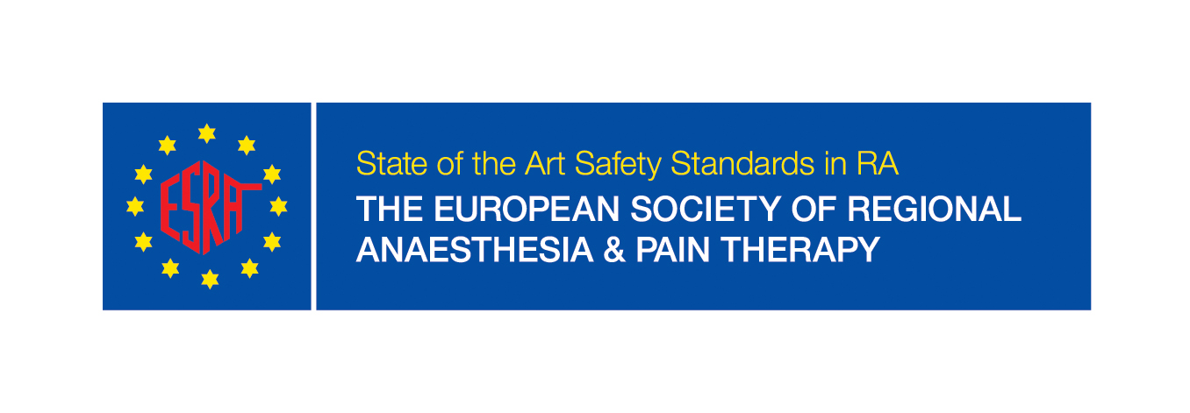

Application form for training institutions

Institution

Name: Click here to enter text.
Address: Click here to enter text.
Website: Click here to enter text.

Date of application: Click here to enter text.

Professor or Head of Department
Email and contact details: Click here to enter text.
No of hospital beds: Click here to enter text.
Approx. no surgery per year: Click here to enter text.
RA training program ☐ yes ☐ no
Details: Click here to enter text.
Pain Medicine ☐ yes ☐ no
Details: Click here to enter text.
Research areas and publications in the last 5 years:
Click here to enter text.

Responsible Clinical Lead

ESRA member: ☐ yes ☐ no
Email & contact details: Click here to enter text.
Please attach CV

Teaching staff members

ESRA member ☐ yes ☐ no
Emails & contacts details (max 5)
Click here to enter text.

Training offered

☐ Regional anaesthesia
☐ Pain medicine

RA
☐ Upper limb / ☐ lower limb / ☐ thoracic / ☐ abdominal / ☐ reconstructive / ☐ cosmetic / ☐ Paediatrics / ☐ maternity / ☐ head and neck / ☐ spinal surgery

PAIN
☐ Interventional pain / ☐ SCS / ☐ multidisciplinary

Duration

Weeks / months: Click here to enter text.
Observer / Hands –on: Click here to enter text.

Accommodation

Available ☐ yes / ☐ no

Restriction

On EU or non-EU doctors – please specify
Click here to enter text.

Additional information to ESRA website:

Please provide information or link.
Click here to enter text.

Support from the ESRA national society:

Please send your application and documents to office@esraeurope.org
ESRA Office, Avenue Florimont 4, 1006 Lausanne, Switzerland
Tel: +41 22 510 56 10 Fax: +41 22 510 56 14
Please attach a letter of support from your national society.

