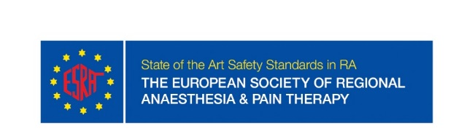
ESRA Research Grant Application
Applicant details (primary investigator):
First name: Click here to enter text.
Last name: Click here to enter text.
Email address: Click here to enter text.
ESRA member: ☐ Yes ☐ No

Head of the research program details:
First name: Click here to enter text.
Last name: Click here to enter text.
Email address: Click here to enter text.
Institution’s name: Click here to enter text.
ESRA member: ☐ Yes ☐ No

Documents to attach:
- Applicant’s short CV (please include publications, presentations, grants, awards or prizes)
- Academic Mentor commitment (very short CV including publications)
- Study protocol including: Short introduction, primary and secondary aims/hypotheses, methods and statistics (group size estimation, data presentation and statistical tests)
- Research time line and cost plan with specification of expenses
- Ethics committee approval (or animal research approval if appropriate)

Checklist (please tick the box if complete):
☐ Applicant ESRA member
☐ Mentor ESRA member
☐ Ethics Committee approval
☐ Study protocol complete
☐ Research done in Europe
Please send your application and documents to office@esraeurope.org
ESRA Office, Rue de Chantepoulet 10, 1201 Geneva, Switzerland
Tel: +41 22 510 56 10 Fax: +41 22 510 56 14

