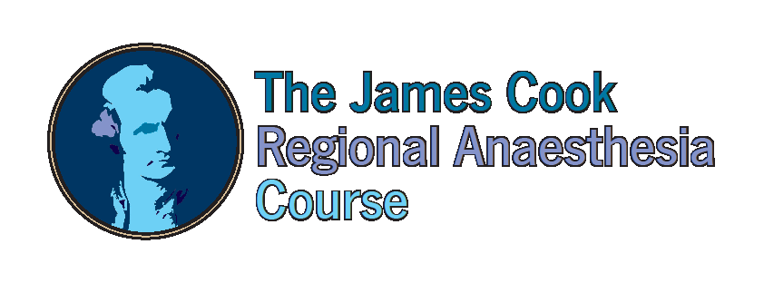

15th Feb – 16th February 2019
Sheraton Dubai
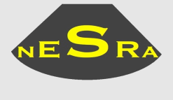

The JCRAC will be held for the first time in the beautiful city of Dubai

Royal College of Anaesthetists UK CPD Applied (expected 12 points)
ESRA CME Applied (Previously approved for ESRA Diploma)

Early Registration before Dec 2018 $ 350 Late Registration $ 500
Apply online at www.jcrac.co.uk or complete and return the attached application form.
Further information contact zoe.holland@stees.nhs.uk or 0044 1642 282825

- Royal College of Anaesthetists Approved Course
- Small group work teaching (5 delegates per instructor)
- Live scanning on volunteers
- Hands-on learning of needle techniques and catheters on phantoms
- Opportunity to discuss tips and tricks with international experts in ultrasound regional anaesthesia
- Spaces limited to 100 delegates

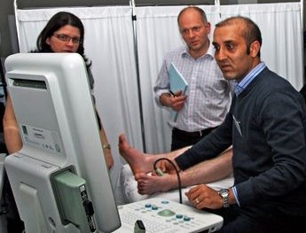
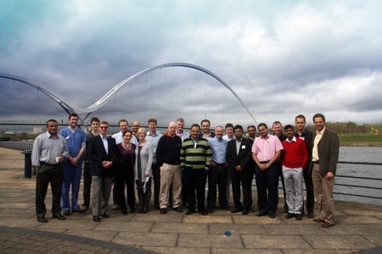
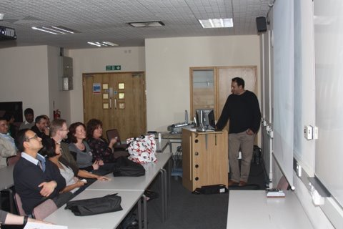

§
“A superb course and very well organised. The speakers were all excellent”
"This was probably the best course I have been to in ten years. The cadaveric anatomy was informative, well managed and refreshing"
“This was the best workshop that I attended in years, I learned so much”
“A truly brilliant day - I would recommend" this course to all my colleagues”

DAY ONE  08.30 Registration & Coffee  09.00 Multimedia presentation for Upper Limb (Dr T Adams)  Anatomy:  09.45 Station 1: Supraclavicular  10.20 Station 2: Axilla  10.55 Station 3: Interscalene  11.30 Station 4: Infraclavicular  12.05 Lunch & Trade Exhibition  13.05 Station 5: Sup Cervical, Axillary N & Suprascapular  13.40 Station 6: Rad, Med, Ulnar, Cut Ns of forearm  14.15 Station 7: PECS 1, PECS 2, Serratus plane  14.50 Station 8: Greater Occipital Nerve & Suprazygomatic Maxillary N  15.25 Coffee Break  15.55 Station 9: Paravertebral  16.30 Station 10: Erector Spinae  17.05 Closure | DAY TWO  08.30 Registration & Coffee  09.00 Multimedia presentation for Lower Limb (Dr John McDonell)  09.30 Multimedia presentation for Other Blocks (Dr Rafael Blanco)  10.00 Station 1: Lumbar Plexus  10.30 Station 2: Popliteal  11.00 Station 3: Ankle  11.30 Station 4: Neuraxial and Caudal  12.00 Lunch & Trade Exhibition  13.00 Station 5: Saphenous, Obturator & Adductor Canal  13.30 Station 6: Phantom & Catheter techniques  14:00 Station 7: Rectus sheath, TAP, llio-inguinal & Quadratus Lumborum  14.30 Coffee Break  15.00 Station 8: Femoral, LFCN & Fascia iliaca  15:30 Station 9: Free scanning  16.00 Station 10: Sciatic  16.30 Closure

FACULTY

Dr Ahmed Aziz, Course Director, Tawam/John Hopkins Hospital, UAE
Dr Rafael Blanco, Kings Hospital, UAE
Dr Baskar Manickam, Darlington Hosp, UK
Dr Anthony Adams, Lancashire Teaching Hospitals, UK
Dr Amr Abdelaal, Addenbrooke Hospital, UK

Dr Tahir Bashir, Tawam Hospital, UAE

Dr Adel El Maytamy. Tawam Hospital, UAE

Dr Omar Elkhatab, Mediclinic Hospital, UAE

Dr Gabrielle Finn, Senior Lecturer, Hull York Medical University, UK

Dr Ashwani Gupta, Queen Elizabeth Hospital, UK

Dr Rola Hammond, Clemenceau Hospital, Lebanon

Dr Nat Haslam, City Hospitals Sunderland, UK

Miss Zoe Holland

, ames Cook University Hospital, UK

Dr Gabriella Ioham, Cork University Hospital, UK

Dr Ranj Khaffaf, Prince Charles Hospital, UK

Dr Mansour, Rashid Hospital, UAE
Dr Riaz Khan, Tawam Hospital, UAE

Dr Brian Kinirions, Galaway University Hospital, Ireland
Dr Patrick Narchi, Soyaux Centre Clinical, France
Dr Ahmed Elreafy, Cambridge Hospital, UK
Dr Amar Salti, SKMC Hospital, UAE
Dr Adrian Searle, Royal Derby Hospital, UK
Dr Pandy Seema, NMC Hospital, UAE
Dr Walid Rayad, Korniche Hospital, UAE
Dr Ahmed Taha, Healthpoint Hospital, UAE
Dr Veerabadran Velayutham, Lancashire Teaching Hospital, UK

